**Language Learning Database Management System**

**Business Problems:**

1. **Resource Accessibility:** High-quality learning resources may be difficult for language learners to access, especially if they are spread across several platforms or repositories. The learning materials are centralized by this system, which facilitates users access to and discovery of the tools they require to assist in their language learning process.
2. **Data Inconsistency:** The accuracy and dependability of learner records may be impacted by inconsistent data entry procedures and a lack of data validation tools.
3. **Restricted Data Accessibility:** Administrators and instructors are unable to effectively retrieve and utilize learner information for program management and decision-making when there is a lack of accessibility or poor organization of the data.
4. **Language-Based Content Personalization:** Language processing is used in language-based content personalization to examine user behavior, preferences, and skill levels. To improve user engagement and satisfaction, this customizes marketing messages and content recommendations.
5. **Progress Monitoring:** The Language Learning System offers progress monitoring tools to track each user's performance efficiently, aiding instructors and administrators in identifying areas where additional assistance may be needed.
6. **Cost Efficiency:** Cost efficiency is increased by centralizing language learning data and resources into a single system, which lowers expenses for staff time, software licenses, and system maintenance.
7. **Administrative Overhead:** With the usage of this system, the administrative tasks associated with language learning programs should be simplified, saving time and energy on maintaining user profiles, monitoring progress, and setting up course materials.

**ER Diagram:**

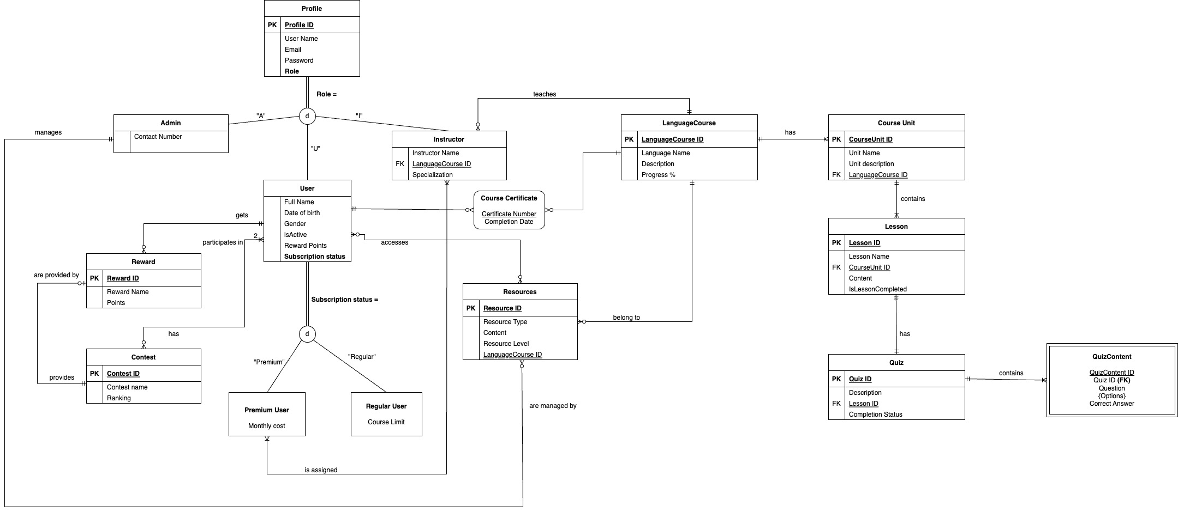

**Business Rules:**

1. User & Language Course: A user can enroll in many courses, but a course can have one or many users enrolled in it.
2. Language Course & Lessons: A course can have many lessons, but a lesson can only belong to one course.
3. Resource & LanguageCourse: Resource should be associated to only one language, but language may or may not have resources.
4. LanguageCourse & Course Unit: A languagecourse can have a unit or multiple units, and unit should have a mandatory languagecourse.
5. Users must be authenticated before they can access the system. This helps to ensure that only authorized users can see sensitive data, such as learning progress and quiz results.
6. Only subscribed users (Premium or Regular) can access certain courses and resources.
7. A premium subscriber will be assigned an instructor, and an instructor can only teach one language.
8. Users can earn rewards based on their activity, like completing courses or quizzes.
9. Resources are linked to relevant courses and categorized by type.
10. Quizzes are associated with specific courses and contain questions relevant to the course content.
11. Admin can upload, modify, or delete learning resources from the system.
12. One or more rewards may be awarded in a contest, and participation from at least two users is required.
13. Contest is not specific to any resource/language course.
14. When the languagecourse is 100 % progressed then an user can get a course certificate.

**Design Decisions:**

|  |  |  |
| --- | --- | --- |
| **Entity** | **Entity Description** | **Entity Relationship to other Entities** |
| Admin | The Admin entity represents administrators or superusers who have elevated privileges within the system. Admins typically have the authority to manage resources. | Admins may have relationships with other entities such as Resources. They may oversee the creation and management of language resources. |
| Profile | The profile entity represents individuals who have registered accounts on the language learning platform. Profiles  can include students, instructors, and administrators, each with their own set of privileges and access levels. | Profile is a supertype. |
| User | User enrolls in courses, they access learning resources and participates in contest. They are also eligible for earning rewards. | User is a subtype of profile, user is a super type for premium and regular user. User has many to many relationship with courses, resources. User has one to optional many relationship with contest |
| Instructor | The Instructor entity represents individuals responsible for teaching and guiding premium users through language courses. Instructors may teaches premium users and provide feedback. | Instructors have relationships with premium users and courses. |
| LanguageCourse | The LanguageCourse entity represents structured language learning courses offered on the platform. Each LanguageCourse typically covers a specific language and may consist of multiple units, lessons, quizzes, and resources. | LanguageCourses have relationships with CourseUnits. Users enroll in LanguageCourses, progress through units and lessons, complete quizzes, and access resources to learn the language. |
| Contest | The Contest entity represents competitive events or challenges organized within the language learning platform. Contests may include language proficiency tests, quizzes, or challenges with rewards for top performers. | Contests have relationships with Users, Rewards. Users participate in contests, earn rewards based on their performance. |
| Resource | The Resource entity represents learning materials, such as textbooks, videos, or interactive exercises, available to users for language learning purposes. | Resources are associated with LanguageCourses and Users. Users access resources to supplement their learning experience within language courses. |
| Quiz Content | The QuizContent entity represents the content or questions included in quizzes or assessments within language courses. Quiz content may consist of multiple-choice questions, fill-in-the-blank exercises, or other interactive tasks. | QuizContent is associated with Quizzes. It defines the questions or tasks that users must complete as part of quizzes within language courses. |
| Reward | The Reward entity represents incentives or rewards offered to users for their achievements within the language learning platform based rankings. | Rewards are associated with Contests, Users. Users earn rewards by participating in contests, achieving milestones, or demonstrating proficiency in language learning tasks. |
| Course Certificate | The Course Certificate associative entity represents a document or recognition awarded to users upon completion of a language course. It serves as proof of achievement and may include details such as course name, completion date, and user information. | Course Certificates are associated with Users, LanguageCourses, and Lessons. Users receive course certificates upon completing language courses, fulfilling specific criteria, and achieving proficiency milestones. |
| Quiz | The Quiz entity represents assessments or evaluations conducted within language courses to test users understanding and proficiency. Quizzes may include various types of questions, such as multiple-choice, true/false, or open-ended. | Quizzes are associated with Lessons, QuizContent. Users take quizzes as part of language lessons, complete quiz content, and receive feedback. |
| Lesson | The Lesson entity represents individual learning modules within language units. Lessons typically cover specific topics, skills, or language concepts and may include instructional content, activities, and assessments. | Lessons are associated with CourseUnits, Quizzes. Users progress through lessons within language courses, complete associated quizzes. |